SRP–SF
Please rate the degree to which you agree with the following statements. You can be honest because your name will be detached from the answers as soon as they are submitted.

1 | 2 | 3 | 4 | 5
Disagree Strongly | Disagree | Neutral | Agree | Agree  Strongly

- I’m a rebellious person. _______
- I have never been involved in delinquent gang activity. _______
- Most people are wimps. _______
- I’ve often done something dangerous just for the thrill of it. _______
- I have tricked someone into giving me money. _______
- I have assaulted a law enforcement official or social worker. _______
- I have pretended to be someone else in order to get something. _______
- I like to see fist-fights. _______
- I would get a kick out of ‘scamming’ someone. _______
- It's fun to see how far you can push people before they get upset. _______
- I enjoy doing wild things. _______
- I have broken into a building or vehicle in order to steal something or vandalize. _______
- I don’t bother to keep in touch with my family any more. _______
- I rarely follow the rules. _______
- You should take advantage of other people before they do it to you. _______
- People sometimes say that I’m cold-hearted. _______
- I like to have sex with people I barely know. _______
- I love violent sports and movies. _______
- Sometimes you have to pretend you like people to get something out of them. _______
- I was convicted of a serious crime. _______
- I keep getting in trouble for the same things over and over. _______
- Every now and then I carry a weapon (knife or gun) for protection. _______
- You can get what you want by telling people what they want to hear. _______
- I never feel guilty over hurting others. _______
- I have threatened people into giving me money, clothes, or makeup. _______
- A lot of people are “suckers” and can easily be fooled. _______
- I admit that I often “mouth off” without thinking. _______
- I sometimes dump friends that I don’t need any more. _______
- I purposely tried to hit someone with the vehicle I was driving. _______

SRP-SF Descriptives

Interpersonal items: 7, 9, 10, 15, 19, 23, 26
Affective items: 3, 8, 13, 16, 18, 24, 28
Lifestyle items: 1, 4, 11, 14, 17, 21, 27
Antisocial: 20 or 2, 5, 6, 12, 22, 25, 29
(Note: for CFA modeling #20 can be replaced with #2 for offenders due to likely limited variance of the former, but both items can be used for forming the SRP-SF total score composite)

Oregon community sample
Descriptive Statistics
 | N | Minimum | Maximum | Mean | Std. Deviation
srp_int | 638 | 7.00 | 27.00 | 11.6442 | 3.48899
srp_aff | 638 | 7.00 | 27.00 | 10.4796 | 3.23522
srp_lif | 638 | 6.00 | 26.00 | 11.8323 | 4.22355
srp_ant | 638 | 6.00 | 26.00 | 7.8668 | 2.88875
SRP_29 | 638 | 26.00 | 84.00 | 41.8229 | 10.59686
Valid N (listwise) | 638

Texas college sample
Descriptive Statistics
 | N | Minimum | Maximum | Mean | Std. Deviation
srp_int | 788 | 7.00 | 32.00 | 14.3325 | 5.03317
srp_aff | 788 | 7.00 | 30.00 | 13.8655 | 4.63944
srp_lif | 788 | 7.00 | 32.00 | 15.8071 | 4.98061
srp_ant | 788 | 8.00 | 30.00 | 11.0622 | 3.83986
SRP_29 | 788 | 29.00 | 116.00 | 55.0673 | 15.05245
Valid N (listwise) | 788

Wisconsin male offender sample
Descriptive Statistics
 | N | Minimum | Maximum | Mean | Std. Deviation
srp_int | 304 | 7.00 | 35.00 | 17.6842 | 5.49578
srp_aff | 304 | 7.00 | 33.00 | 17.8257 | 4.57564
srp_lif | 304 | 8.00 | 35.00 | 20.9770 | 5.09476
srp_ant | 304 | 8.00 | 40.00 | 20.9803 | 5.64338
SRP_29 | 304 | 35.00 | 127.00 | 77.4671 | 17.31647

4-factor model-Texas sample (TLI = .93, SRMR = .07)

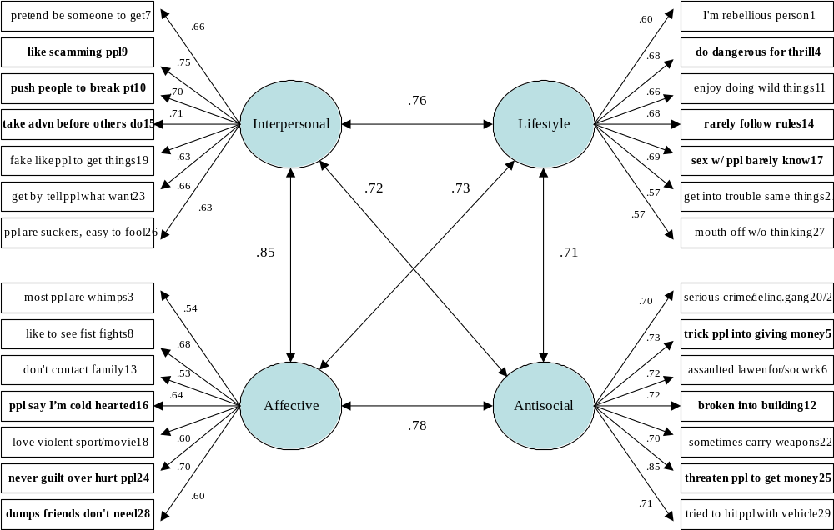
SRP-SF means by males, females (Texas Sample)

Report
gender |  | srp_int | srp_aff | srp_lif | srp_ant | SRP_29
1 male | Mean | 16.0980 | 16.0539 | 17.4216 | 12.5196 | 62.0931
1 male | N | 204 | 204 | 204 | 204 | 204
1 male | Std. Deviation | 5.42210 | 4.69798 | 5.24463 | 4.48145 | 15.94437
2 female | Mean | 13.6718 | 12.7752 | 14.9793 | 10.4574 | 51.8837
2 female | N | 387 | 387 | 387 | 387 | 387
2 female | Std. Deviation | 4.70457 | 4.26925 | 4.67377 | 3.33767 | 13.55757
Total | Mean | 14.5093 | 13.9069 | 15.8223 | 11.1692 | 55.4078
Total | N | 591 | 591 | 591 | 591 | 591
Total | Std. Deviation | 5.09198 | 4.68533 | 5.01056 | 3.89373 | 15.20931

